**Motor Sequence Learning Experiment**

PSY310: Lab in Psychology

17th October 2024

Twisha Shah

AU2220062

**Github link:**

**Introduction:**

Learning is a fundamental cognitive process that involves acquiring new knowledge and skills. Contingency, the relationship between behavior and outcomes, plays a crucial role in learning. Sequence learning, where individuals recognize and anticipate patterns, is a prime example of how contingency influences learning (Cleeremans & McClelland, 1991). Contingency affects learning in various ways, in which sequence learning where learners identify and learn about sequences, is an example (Abrahamse et al., 2013). To determine the participants’ learning rate and their retention of sequential information.

**Method**

The experiment was conducted on the PsychoPy app (v2024.1.5). Each trial consisted of a set of stimuli being displayed in either a planned sequence or randomly (50-50). A total number of trial was 400, Subject were encouraged to give a response as soon as they detected the triangle or where they expected the next element of the sequence to appear. The time taken to respond by the participant was also measured by the average reaction time (RT) for each trial. The experiment was divided into two main conditions: where the sequence of allocation was fixed and followed a particular sequence throughout different trials, and random, where the sequence of allocation was changed between the trials.

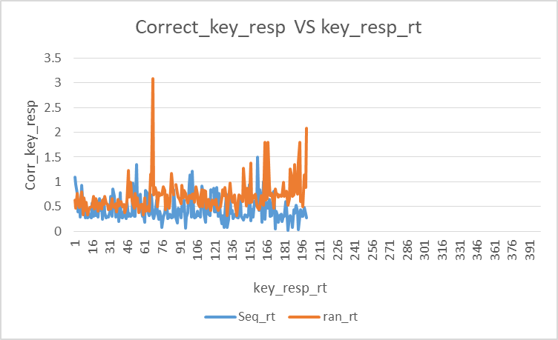

**Results:**

The mean RT for all the sequence trials is 0.445291014

The mean RT for all the random trials is 0.697455575

It also emerged that the mean reaction times reduced between the two conditions suggested that they were influenced by the paradigm type; that is, the reaction times under the sequential and random conditions were significantly different. More so, participants had a faster RT in the sequential condition (Mean = 445 ms) than in the random condition (Mean = 697 ms). A plot illustrating RT as a function of the trials demonstrated that the participants improved in the sequential condition as the number of trials increased; however, the RT’s in the random condition presented similar RT’s to that of the initial trial.

**Discussion:**

The manipulation performed here is that there were two types of sequences used: the sequential and the random, and the difference between these two may be explained by the fact that in the first type of sequence, participants expect some next cue to follow. In sequential trials, participants could guess what is going to come next and respond faster than in random trials where unpredictable trials required more mental work and also an effort to solve in sequence, therefore making the RT slower. The graph shows the correct key response with key response reaction time. We can see from the results that, the reaction time for the sequence condition was less than that of the random condition.

**References:**

Abrahamse, E. L., Ruitenberg, M. F. L., De Kleine, E., & Verwey, W. B. (2013). Control of automated behavior: insights from the discrete sequence production task. Frontiers in Human Neuroscience, 7. <https://doi.org/10.3389/fnhum.2013.00082>

Cleeremans, A., & McClelland, J. L. (1991). Learning the structure of event sequences. Journal of Experimental Psychology General, 120(3), 235–253. <https://doi.org/10.1037/0096-3445.120.3.235>